Linux install

Wsl install

Task 1:

Create a Directory with the Name Linux Practice.

 Hint: use mkdir LinuxPractice

Task2:

Change to the directory

 Hint: use cd .\LinuxPractice\

Task 3:

Create a file name TestFile1.txt and add the content to it.

Task 4:

Create a Folder named Dummy and try to delete it.

Task 5:

Plz check the working directory (Hint : pwd)

Task 6:

How do you check all the files and directories in the directory you are in?

Task 7:

Create five files named TestFile2.txt.. TestFile3.txt… and so on till TestFile6.txt

Task 1-7

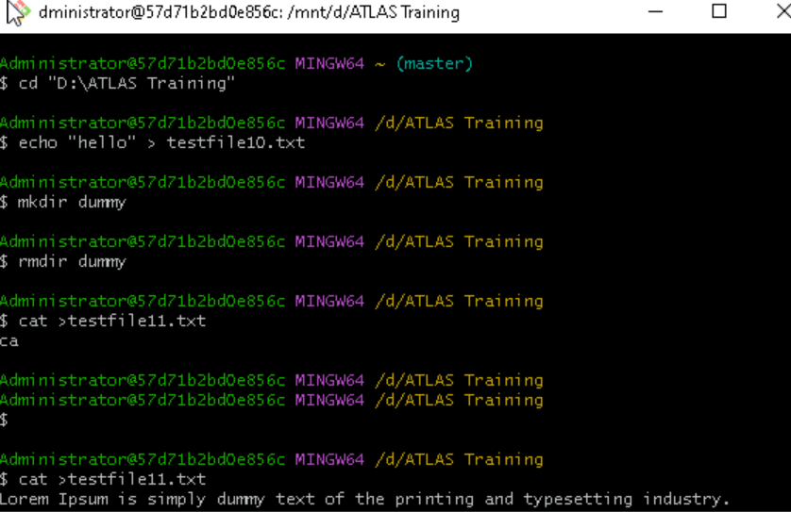

Task 9 10

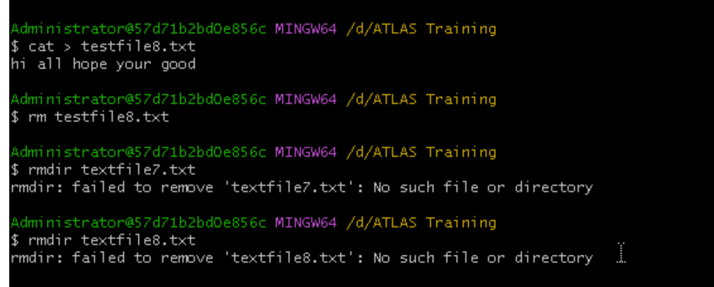

Task : 11 12 13 14

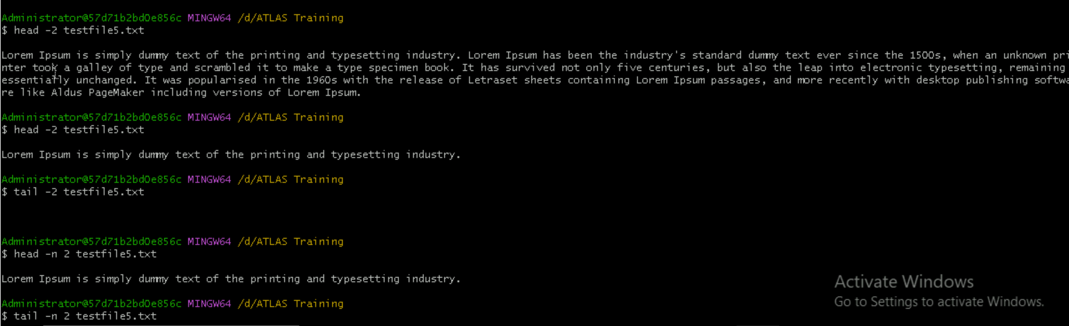

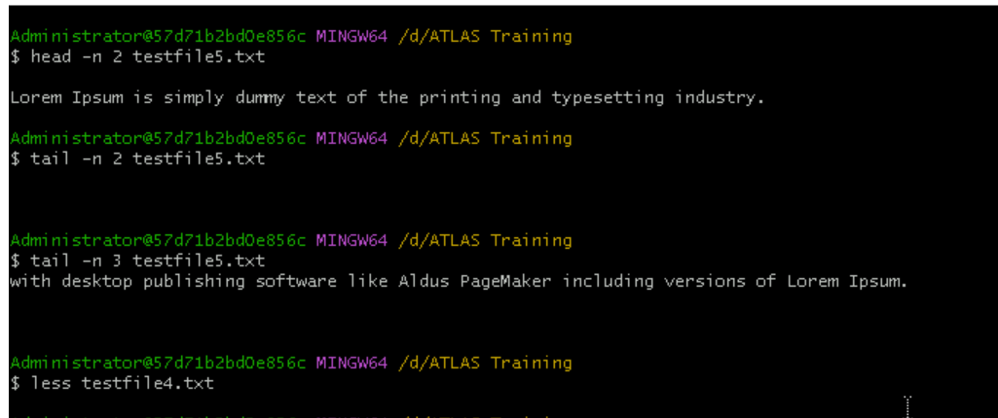

Task 15 :

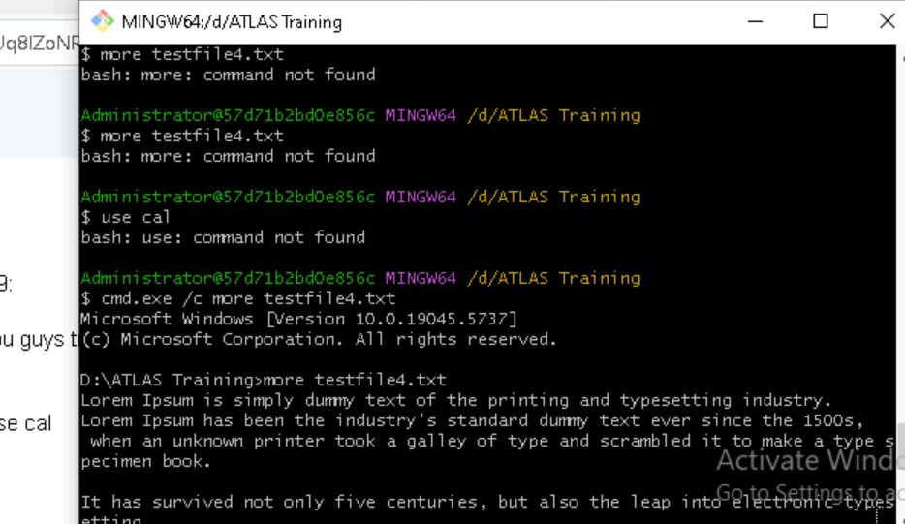

Task 17 :

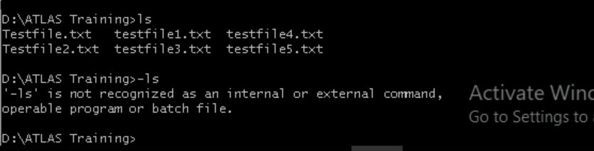

Task 20 21 22 23

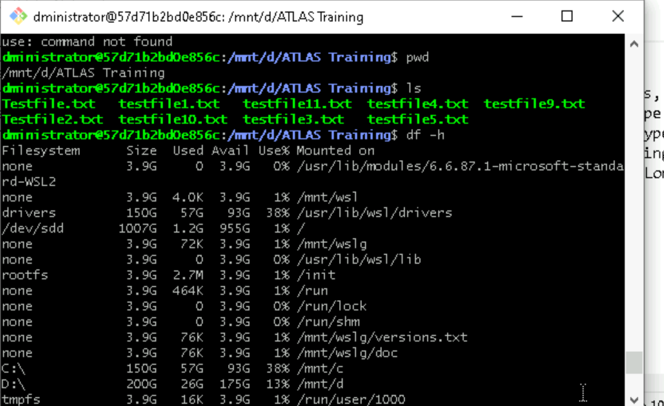

Task 24

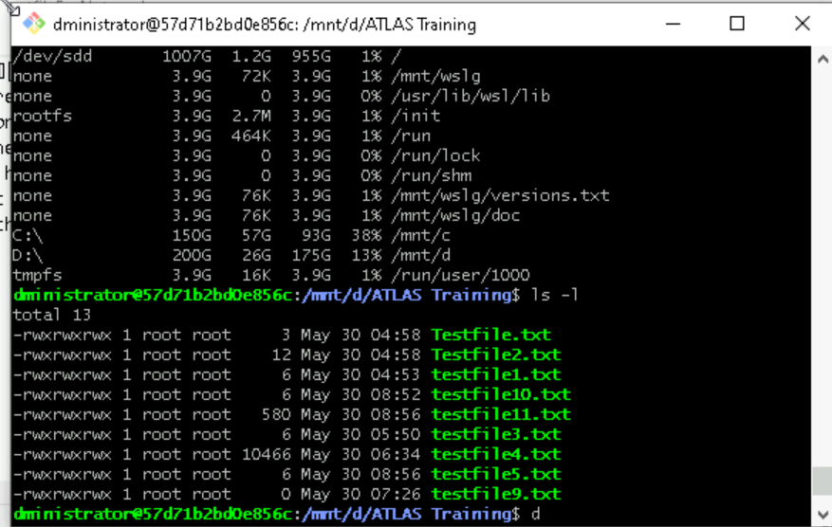

Task 22

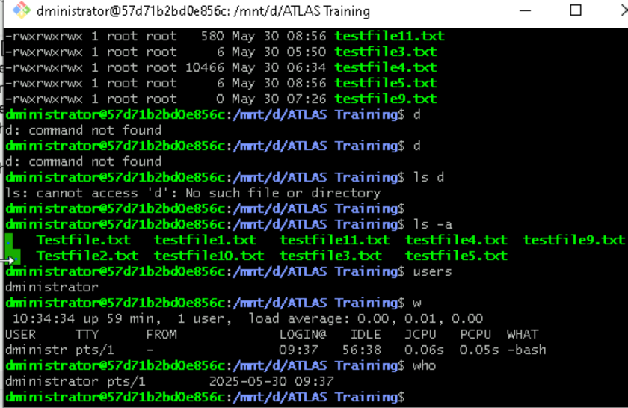

Task 29 :

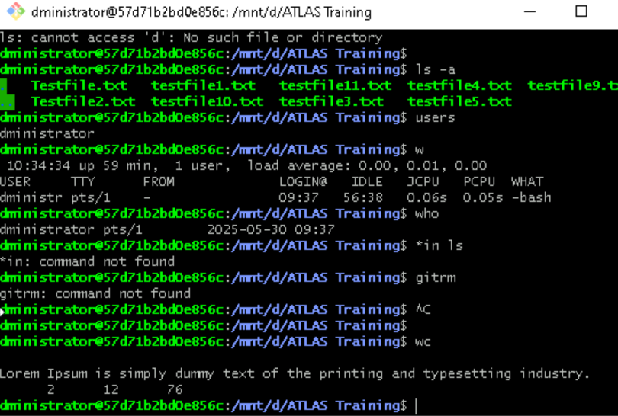

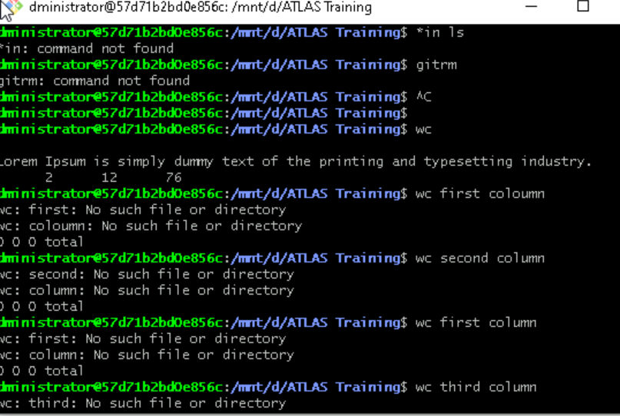

Task 28-31

